AUTOMATIC FAUCET

By

BIT15-6

EMBEDDED SYSTEM

DEPARTMENT OF INFORMATION TECHNOLOGY

SCHOOL OF COMPUTING AND INFORMATICS TECHNOLOGY

A Project Report Submitted to the School of Computing and Informatics Technology

for the Study Leading to a Project in Partial Fulfilment of the

Requirements for the Award of the Degree of Bachelor of

Information Technology of Makerere University.

Supervisor

Mrs. Alice Nandawula Mugisha

Department of Information Technology

School of Computing and Informatics Technology, Makerere University

amugisha@cis.mak.ac.ug , +256 702 429 228

April 2015

GROUP MEMBERSHIP:

|  |  |  |  |
| --- | --- | --- | --- |
| **#** | **Names** | **Registration Number** | **Signature** |
| 1 | Katusabe Kenneth | 12/U/6562/PS |  |
| 2 | Mugisha Maurice | 12/U/8757/PS |  |
| 3 | Gumisiriza Innocent | 12/U/283 |  |
| 4 | Naggayi Teddy | 12/U/765 |  |

## Declaration

We the members of group BIT15-6 declare that this is our original work, and has never been submitted to any institution of higher learning for any award.

## Approval

This work and project report has been compiled, put together and submitted to the School of Computing and Informatics Technology, Makerere University for examination with the approval of;

**Signature:**……………………………………………….

**Date:**……………………………………………….…….

Mrs. Alice NANDAWULA MUGISHA

Department of Information Technology, Makerere University.

**Project Supervisor.**

## Acknowledgement

We wish to extend our heartfelt sincere gratitude to the Almighty God for the gift of life and for having enabled us pass through this period with utmost good health and tireless effort to undertake this task.

We also take this opportunity to express our profound deep sense of gratitude to our guide/project supervisor Mrs. Alice Mugisha, School of Computing and InformaticsTechnology, Makerere University Kampala. She provided us the best and most convenient guidance there is throughout the course of the project. We also can’t forget to recognize the great help and support provided to us by Ms. Mary Nsabagwa and Mrs. Doreen Tuheirwe Namukasa, all of the School of Computing and Informatics Technology, Makerere University Kampala. We are very thankful for all the help we received.

## Dedication

We dedicate our works to all the victims of the Ebola Virus Disease (EVD) in West Africa, in the countries of Liberia, Sierra Leone, Nigeria and all places in the world where the disease has claimed thousands of lives.

## **Table of Contents**

Declaration 1

Approval 2

Acknowledgement 3

Dedication 4

Table of Contents 5

List of Tables 8

List of Figures 9

List of Acronyms 10

Abstract 11

Chapter 1 12

1.0 Introduction 12

1.1 Background to the Problem 13

1.2 Problem Statement 14

1.3 Objectives 15

1.3.1 Main Objective 15

1.3.2 Other Objectives 15

1.4 Scope 15

1.5 Significance 15

Chapter 2 16

2.0 Literature Review 16

2.1 Introduction 16

2.2 The Automatic Faucet System 16

2.2.2 Circuit Components 17

2.2.3 The Interoperability of the Circuit Components 19

2.3 Why use Automatic Faucets 20

2.4 Previous Research on Automatic Faucets 21

2.4.1 Existing Automatic Faucets 22

2.5 Conclusion 24

Chapter 3 25

3.0 Methodology 25

3.1 Questionnaire 25

3.2 Observation 25

3.3 Interviewing 26

3.4 Research and Site Visits 26

3.5 System Design 26

3.6 System Development and Implementation 27

3.7 System Testing 27

Chapter 4 28

4.0 System Study, Analysis & Design 28

4.1 System Study 28

4.1.1 Existing Automatic Faucet Systems 28

4.1.2 Existing Manual Faucet Systems 30

4.1.3 Conclusion 30

4.2 System Analysis 31

4.2.1 Research Findings 31

4.2.2 Requirements 36

4.3 System Design 40

4.3.1 Requirements and Process Modelling 40

Chapter 5 51

5.0 System Implementation, Testing & Validation 51

5.1 System Development & Implementation 51

5.1.1 Software Technologies. 51

5.1.2 Hardware Technologies. 52

5.1.3 Implementation of the Hardware and Software Technologies. 53

5.2 System Testing & Validation 54

5.2.1 System Testing 54

5.2.2 System Validation 55

Chapter 6 56

6.0 Discussion, Conclusion & Recommendations 56

6.1 Discussion 56

6.1.1 Experiences. 56

6.1.2 Achievements 57

6.1.3 Limitations 57

6.2 Conclusion 57

6.3 Recommendations 58

References 59

Appendices I

Appendix A: Research Tools I

i. Questionnaire I

ii. Observation Checklist II

iii. Interview Guide III

Appendix B: Work Plan IV

## List of Tables

Table 1: Hardware Requirements needed to come up with an Automatic Faucet System 38

Table 2: Software Requirements needed to model the Automatic Faucet System 39

Table 3: Software Technologies used to develop the Automated Faucet System. 52

Table 4: Hardware Components used to implement the Automated Faucet System. 52

Table 6: A table showing the work plan for developing the Automatic Faucet System IV

## List of Figures

Figure 1: A pie chart showing the gender distribution of the respondents. 31

Figure 2: A pie chart showing the level of restroom usage. 32

Figure 3: A pie chart showing the level of satisfaction with hygiene 33

Figure 4: A pie chart showing awareness of contracting infectious diseases. 34

Figure 5: A pie chart showing willingness to use a touch free water faucet. 35

Figure 6: A pie chart showing the willingness to use a touch free soap dispenser. 36

Figure 7: Automatic Faucet System Architectural Design 40

Figure 8: State machine diagram of the Automatic Faucet System 44

Figure 9: Sequence diagram of the water dispensing module. 46

Figure 10: Sequence diagram of the soap dispensing module. 49

Figure 11: Questionnaire used to collect data I

Figure 12: Observation Checklist used during the observation process. II

Figure 13: Interview Guide used during data collection III

## List of Acronyms

|  |  |
| --- | --- |
| **Acronym** | **Meaning** |
| AC | Alternating Current |
| CDC | Center for Disease Control, USA |
| CPU | Central Processing Unit |
| DC | Direct Current |
| EMF | Electro-Motive Force |
| EVD | Ebola Virus Disease |
| HD | High Definition |
| IR | Infrared |
| LCD | Liquid Crystal Display |
| LED | Light Emitting Diode |
| RAM | Random Access Memory |
| SDLC | System Development Lifecycle |
| UML | Unified Modelling Language |
| USS | Ultra-Sonic Sound Sensor |
| USB | Universal Serial Bus |
|  |  |

## Abstract

An automatic faucet is a regulator for controlling the flow of water through the tap spouts basing on inputs from sensors. Automatic faucets are mainly used in health facilities and public areas such as airports, night clubs among other public areas. In a similar way, the automatic faucet system was developed and is intended to be applied in the lavatories of Makerere University plus other public places in the university where hand washing is done. Used by a very large number of students, the toilets in Makerere University are still equipped with manual faucets which are associated with a lot of physical contact that brings about vandalism of such installations. The system was therefore intended to address the need to eliminate the rebirth of the problem of contact that increasingly came into play when the use of soap became a major recommendation for proper hand washing. On the other hand, the automatic faucet systems in existence were also observed to be susceptible to this problem. This was therefore the major reason for the development of an automatic faucet system that automatically dispenses water and liquid soap.

The main objective was therefore to develop an automatic faucet that will help in controlling the spread of infectious and contagious diseases. The system design was based on a number of UML based techniques which included the use of a state machine and sequence diagrams as well as a block diagram for the modelling of the states, processes, and the system architectural design respectively. The design results included a schematic or circuit diagram from which the automatic faucet system’s electrical components were assembled. The appropriate code to run the system components from which a working system came into existence was written thereafter. Tested in a real world environment, the errors and missing functionality during development were identified and corrections were made.

Preceded by all the above,major conclusions about the developed automatic faucet system were reached. A number of recommendations were also made in order to give a direction for future research in relation to automatic faucet systems. These included; integrating the system with mobile technology in order to improve the way in which the system notifies sanitary workers about the outage of liquid soap and eliminate the dependency on the Liquid Crystal Display, tracking and monitoring the amount of liquid soap used in a given period of time to provide accountability of vital resources like liquid soap among other recommendations.

# Chapter 1

## 1.0 Introduction

A faucet is a regulator for controlling the flow of water from a reservoir (Wikipedia, 2015). It mainly constitutes a tap and a water sink. When automated, a faucet is usually made touchless giving rise to an automatic faucet. An automatic faucet is equipped with a proximity sensor and a mechanism that opens its valve to allow the flow of water in response to a detection of the presence of hands. It is therefore a major tool for ensuring sanitation or public health if used in public lavatories (Wikipedia, 2014). It is for this reason that automatic faucets are used at airports, in public office buildings, night clubs, homes, hospitals, hotels as well as in many other places where public health is a concern.

The use of automatic faucets is simply one of the many other ways in which public health can be addressed. Public health is simply the science of protecting and improving the health of families and communities through promotion of research for disease and injury, prevention, detection and control of infectious diseases (Centre for Disease Control, USA, 2014).  
With two major underlying principles in public health programs which are; prevention rather than the treatment of diseases and addressing the health needs of populations as a whole instead of individuals, public health is undoubtedly necessary(Office of the Provincial Health Officer, Ministry of Health, British Columbia, ND).The application of automatic faucets therefore seeks to prevent the transmission rather than cure any diseases/infections that come as a result of contact through hand washing.

Hand washing being the most effective means to curtail infection transfer, the study intends to make a contribution to public health through ensuring that hand washing is safer than before.This is through proper hand washing with water and soap, avoiding contact with routinely touched surfaces such as faucet or tap surfaces and soap cans(Centre for Disease Control and Prevention, ND). Considering the Ebola Virus Disease (EVD), one of the most prominent contagious diseases, it’s recommended that the risk of both direct and indirect contact between healthy and infected people should be reduced according to the World Health Organization (WHO). Indirect contact is through contact with commonly touched surfaces like liquid soap cans or facets in lavatories.

In a bid to improve public health within Makerere University, public health is being addressed through the provision of water in toilets for better hygiene using faucets. However, the available faucets are not technologically advanced to serve their primary goal due to their mode of usage. These require winding (and unwinding) or even exerting pressure to open or close the flow of water, a procedure that has left most of them broken or even vandalized because they require physical contact.

The study is therefore concerned with how to come up with an automatic faucet.This will in turn mitigate the spread of diseases whosetransmission can be accelerated with the usage of the current water supply installations in public toilets. The study further brings to light the reasons or advantages of using automatic faucets, some of which include reducing water wastage, reducing physical damage among other advantages (Autotaps, 2014). Related cases of the study in terms of case studies are also included under the literature review.

### 1.1 Background to the Problem

Although some strategies and solutions to address public health had been laid earlier in form of the currently used water taps and sinks in public places, the strategies are not effective enough to control the spread of highly infectious and contagious diseases (communicable diseases). This is because contagious diseases are able to spread from one person to another through contact. The spread of contagious diseases through contact can either be direct or indirect. Direct contact involves physical contact between a healthy and an infected person for example through hand shaking. The adverse effect is that the healthy person may contract such a disease due to contact with a negligible amount of body fluids from the infected person’s hands.

On the other hand, the spread of contagious diseases through indirect contact happens in a way that there is a common surface of contact between an infected and a healthy person. When an infected person makes contact with a commonly touched surface for example a tap, a significant amount of his or herbody fluids usually remains on the tap surface. This leaves the other people who get into contact with the tap afterwards at close to the same risk as those exposed to direct contact.An outbreak of a highly communicable disease such as Ebola may utilize such a mode of spread. This therefore rendered the water supply installations providedearlier for purposes of washing hands not effective in achieving the principal goals of public health. This is because the water supply installations required physical contact with the tap, a major component that makes up a faucet through winding and unwinding or at times exerting pressure to have water flowing in order to wash hands. This would in turn give rise to the problem of commonly touched surfaces.

In a bid to improve hygiene through hand washing, automatic faucets were also developed to introduce a touch free use of faucetsin the washing of hands. In order to further improve public health through making hand washing a priority, the use of soap to thoroughly clean hands became a major recommendation and soap has since then been provided to the people that use faucets in not only the different public facilities but also in private places. The soap is provided in form of smaller pieces of solid soap or as liquid soap put in small containers.The combination of the two that is to say, an automatic faucet and a provision of soap makes up a modern hand washing area.

Despite the fact that these changes are very significant, they have not been effective enough in mitigating the spread of germs through contact as anticipated earlier. This is because they require people to physically touch soap or liquid soap containers (cans) and at times contact with their resting surfaces in an attempt to thoroughly wash hands is inevitable. This procedure reintroduces the problem of commonly touched surfaces.This could further orchestrate the spread of highly contagious diseases oblivious to the original goals of providing water in public rest rooms through the use of automatic faucets.

### 1.2 Problem Statement

With the outbreak of a contagious disease for example Ebola, an infected person using the current water installations could infect many other person that will use the same faucet. This makes such public places potential accelerators of the spread of such epidemics. In addition to the spreading of diseases, the manual way of using water taps has left most of these installations mechanically damaged due to poor usage and vandalism thus putting them out of service hence increasing maintenance costs in terms of repair and replacement. Furthermore, there is a lot of water wastage with the existing installations as water taps are sometimes left open.

### 1.3 Objectives

#### 1.3.1 Main Objective

To develop an automatic faucet that will aid in the control of the spread of infectious and contagious diseases.

#### 1.3.2 Other Objectives

* To gather adequate information and requirements about the usage of current water supply installations.
* To design the operation and functionalities of the system based on the gathered requirements
* To implement a working automatic faucet system.
* To test the system in a real world environment in order to identify errors and missing functionality for rectification.

### 1.4 Scope

The study was conducted in Makerere University, Kampala.It was focused on developing an automated faucet system that enhances the supply of water in a way that protects and maintains public health.

The study did not include any pathological details about infectious and contagious diseases but how to mitigate their spreading in public toilets with respect to the known modes of their spread.

### 1.5 Significance

1. Minimized spread of diseases through the reduction of physical contact with the tap and other water supply installations in toilets.
2. Improved personal hygiene through an automated provision of liquid soap for washing hands after visiting a toilet.
3. Reduced water wastage since a person cannot live the water flowing as the system automatically locks the water.
4. Significantly reduced maintenance costs in repairing and replacing broken taps.
5. Convenience and an easy process of using water to clean hands by eliminating the process of determining the direction of winding a tap open.

# Chapter 2

## 2.0 Literature Review

### 2.1 Introduction

This section is a review of the already existing literature about the current water supply installations in form of automatic faucets that are related to the developed project. The project was concerned with the development a completely touch free faucet that automatically releases water or/and liquid soap through one of the two taps’ spouts after sensing hands in front of the faucet. The operation of the system is simple. The system was designed to detect a person’s hands in close range to eitherthe water or liquid soap spout, water or soap is released depending on where the person’s hands are closest. The water flows for as long as the person’s hands are still in range and closes in a very short while after the hands are out of range.

The circuit was constructed using basic electronic components like rectifier diodes, resistors, transistors, relays, a transformer, an Infrared light emitting diode (IR LED) and an infrared light receiver called a photo diode, an Arduino board, an ultrasonic sound sensor, a solenoid valve and jumper wires. The circuit turns on or off the flow of water or liquid soap when hands are detected. The circuit works on a 12Volts (12V) supply and therefore a step down transformer was employed.

### 2.2 The Automatic Faucet System

The section explains the basic principle on which the automatic faucet operates, the components and the interoperability of the components all of which define the technology behind automatic faucets.

**2.2.1 Basic Principle**

The basic principle behind the operation of the automatic faucets is entirely based on the operation principle of a proximity sensor. Infrared is emitted by the infrared light emitting diode. When an object (or hand) is hit by the infrared light, it is bounced back towards the photo diode that then generates an electrical signal from it. Note that infrared light is not visible to the human eye although with a camera, one is able to see it. The amount of infrared reflected back is what can be known as the back scatter (Garrett, Raihan and Will, ND).

#### 2.2.2 Circuit Components

Automatic faucets are created by combining four key components: Solenoid valve, proximity sensor, control electronics, power source, and faucets. Each of these tools has a distinct function that once combined, constitute an automatic faucet. A breakdown of the electronic components used with respect to their purpose is as follows.

1. **Power Source.**

An AC transformer is the power source used. The solenoid valve, mini water pump as well as the sensors and other control electronics require a power source. This readily available component (power source) was crucial to ensure faucet operation. Commonly used alternatives are batteries such as C, AA, 6Volt and 9Volt Lithium batteries (Nyadi, 2012).

1. **Proximity Sensors**

A proximity sensor is an electronic component that is able to detect the presence of a nearby object. The object could be a person or other material. A proximity sensor emits an electromagnetic field or a beam of electromagnetic radiation such as infrared and looks for changes in the field or return signal. It starts by applying a voltage to a pair of infrared light emitting diodes (IR LED) which in turn emit infrared light. The light propagates through air and once it hits an object, it’s reflected back towards the infrared light receiver. If the object is close, the reflected light will be stronger than when the object is far from the emitter. The target object in this case is the human hand(Garrett, Raihan and Will, ND).

1. **Integrated Circuit**

An integrated circuit is a circuit made up of several tiny components and placed in a small package. It is also known as a microcontroller and an example of a microcontroller is the Arduino’s Atmel ATmega328 microcontroller used in Arduino Uno boards. It is used to execute instructions derived from the code written and uploaded to it using a suitable environment. The microcontroller is in other words a processor (Michael, 2008).

1. **Resistor**

Resistors are the most passive electronic components (ones that do not require current to operate). These are used to resist the flow of electrical current through the circuit. They are in other words used to set up (regulate) the correct voltages in the circuit to operate properly. The ability to resist the flow of current is measured in Ohms (Ω) (Nyadi, 2012).

1. **Transistor**

It is a device that restricts or allows the flow of current between two contacts based on the presence or absence of current on the third contact (the base contact). It’s made up of the collector contact denoted by the letter C usually, the Emitter contact also denoted by E as well as the base contact that is represented by B and it is found between the collector and the emitter contacts. The presence of current at the base (B) allows the flow of current between the collector and the emitter and vice versa (Nyadi, 2012).

1. **Rectifier Diode**

A rectifier diode is an electronic component used to conduct electricity in one direction. It is used to prevent the back electromotive force (back EMF) from causing any electrical damage to the producing circuit. The back EMF is therefore a voltage that pushes against the voltage which induces it (Griffiths, 2012).

1. **Relay**

A relay is a device that completes a connection between two contact points by means of a mechanical movement. A relay uses a solenoid (coil of wires) to magnetically move a contact switch. A signal is sent to the relay which can be used as the source of the electromagnet. They are typically used as switching mechanisms allowing for small DC current to switch large AC or DC currents. In this application they are used to isolate the more sensitive control circuitry from the heavy load components that is to say, components with high electrical requirements required to work (Nyadi, 2102).

1. **Breadboard**

A breadboard is a device that facilitates the construction and testing of circuits. Typically they are used for prototyping circuit designs. Later after the design is complete, the breadboard circuit can be soldered on a permanent circuit board using soldering iron (Julien, 2013).

1. **Solenoid Valve**

A solenoid operated diaphragm valve is entrusted with the task of physically starting and stopping water flow. A small number of them use geared motors to achieve valve opening and closing.

1. **Mini Pump**

This is a component used to collect a liquid such as liquid soap from its reservoir to the intended point of use. In this case, to one of the taps’ spout. Depending on how viscus the liquid is,the suction force of the pump can be varied.

#### 2.2.3 The Interoperability of the Circuit Components

The interoperability begins when inputs are detected from the sensors. A person intending to clean his or her hands after visiting a toilet or out of choice brings the hands in front of the faucet spout. The proximity sensor then detects the presence of the hand in front of the water or liquid soap spout. The input is therefore a backscatter of infrared from which an output electrical signal is generated. According to Wikipedia (2015), a sensor is a transducer whose purpose is to detect some characteristics of its environment. A transducer on the other hand is a device that converts variations in a physical quantity, such as sound, presence (proximity), motion among other quantities into an electrical signal. When these changes or events are detected, it provides a corresponding output.

According to Mark (2013), once received, an electric signal is generated from the reflected infrared light from a human hand. The conversion of infrared light into an electrical signal is done by the infrared light receiver. The infrared light receiver is a photodetector that contains a highly electrical conducting material called graphene, a single-atom-thick sheet of carbon. Light is gathered using a silicon guide to enhance its absorption by graphene so that wires can pick up an electrical signal. Graphene can therefore efficiently convert infrared light into an electrical signal that can also be amplified in the connecting circuitry for further processing.

Thereafter, the signal is moved to the microcontroller. The microcontroller processes it in order to execute certain actions for example passing or continuously outputting a 5v current to a transistor through a jumper wire. The transistor acts as the switch which completes the circuit when a 5v supply (or even lesser) is applied to its base (B) to create electrical saturation. This in turn causes a relay to switch to a higher voltage supply for example 12v connected to its common. The higher voltage is what is used to perform heavy load tasks, that is to say, tasks that require higher electrical current for example opening a solenoid valve connected to a water supply of a given pressure. By opening a solenoid valve, it means that water immediately starts flowing due to the pressure.

A redundant circuit can be built for yet another tap on the same faucet whose role is to release liquid soap following similar events and actions. This means that a pump will be used to generate a suction force that brings forth the liquid soap from its reservoir to the tap spout. When a person’s hands are out of range, there ceases to be any input and therefore the microcontroller halts the flow of water or liquid soap from the water and soap tap spouts respectively. In other words, it starts when infrared light is received (reflected off a person’s hand), converted into an electrical signal that is transmitted to the microcontroller in this case the Atmel ATmega328 controller. The microcontroller processes the signal and performs an action in response to the received signal for example issuing an order to output a 5v current to a given output pin. The proximity sensor system is connected to a water supply of a given pressure using one (water input end) end of a solenoid valve. The other end of the solenoid valve (output end) is connected to a tap for soap or water release and of which tap again houses the IR LED and IR LED receiver. This is what constitutes the intended automatic water and liquid soap releasing faucet. The process repeats for all the other subsequent visits to the faucet.

### 2.3 Why use Automatic Faucets

According to Wikipedia (2014), Faucets were first developed in the 1950s but were not produced for commercial use until the late 1980s when they first appeared to the general public at airport lavatories. Because of their assistive qualities, automatic faucets are often found at assistive living establishments and places where the elderly and handicapped call home. Automatic faucets are water saving devices helping to save 70% of the water that would otherwise swirl down the drain unused and conserve as much as three to five percent (3% to 5%) of the water used by a standard household.

According to Charles (2014), great number of people who use public toilets prefer rest rooms with automatic or touch free sinks, soap, and towel dispensers and these are up to nine out of ten (9 out of 10). This greatly enhances rest room hygiene by eliminating the need to touch faucets during use.

A major benefit and focus of automatic faucets was found in inhibiting the spread of germs which are known to thrive on faucet or tap handles. In case the germs are of infectious or contagious diseases like Ebola, the faucet handles and taps would be major areas for the spread of such diseases hence not performing their primary goal (Fadi, 2010).

Airports have thousands of travellers from around the world or countries and the easiest way to transmit germs is through touch. A kitchen faucet often has a lot of germs on it so it’s only logical to have an automatic faucet to prevent the transmission of germs at airports, public places and homes (Dave, 2015).

Automatic faucets to a small extent have also shown a great ability to significantly reduce physical damage which becomes costly through repair and replacement, a major problem faced by manually used faucets (Autotaps, 2014).

Transfer of germs and bacteria that cause infection is one of the greatest health challenges in todays’ health and other public facilities. While there is much work to be done on the scientific front to combat serious infections, there is an easy way to reduce the spread of germs and bacteria. According to the Centre for Disease Control and Prevention (CDC), USA, hand washing is the most effective means to curtail infection transfer.

Proper hand washing is critical in the healthcare sector and touch free plumbing provides the means to ensure hands are washed effectively.(American School and hospital facility magazine facility management, ND).

### 2.4 Previous Research on Automatic Faucets

In order to minimize the spread of infectious and contagious diseases, water wastage, and provide convenience in using water faucets, automatic faucets were introduced in public places like airports, public toilets among other public places. Some of these automatic faucets include Sloan Lumino faucets, Mac faucets among others.

These were found to provide water as expected without the need to have any physical contact with the tap handle. This was attributed to the fact that automatic faucets detect the presence of a human hand and automatically release water by making use of the different components that make up an automatic faucet as described earlier. This greatly reduced the tendencies of interacting with the water faucets through physical contact, a key step in mitigating the spread of germs which cause infectious and contagious diseases (communicable diseases) hence a great improvement in public health (Michael, 2015).

#### 2.4.1 Existing Automatic Faucets

The two most prominent automatic faucet producers, that is Mac Faucets and Sloan Valve define the basis of the intended enhancement in providing a completely touch free usage of faucets.

1. **A case study of Mac Faucets**.

MAC Faucets invented the concept of luxury automatic faucets in the early 2000s. MAC Faucets began with a simple idea: Create hands free, automatic faucets that are reliable, and affordable. With this concept in mind, they embarked on a long and gratifying journey to design and manufacture automatic faucets for discerning clientele.

The first leg of the journey began with the introduction of the AutoLuxe™ faucet line, “The World's First Line of Decorative Automatic Faucets” available in various finishes. Since, they have expanded the selection of faucets and finishes in this line.

Later, MAC Faucets introduced the Industry Standard™ line, redefining the standard in automated bathroom and restroom hardware. The industry standard™ line has expanded, and now includes automatic flush valves and touch less hand dryers. In the ensuing years MAC Faucets introduced the first full line of decorative wall mounted automatic faucets, a full line of hands free vessel sink faucets, and a line of manual soap dispensers. (Fadi, ND).

Although Mac Faucets® is credited for inventing the first automatic faucet, their products are still lacking. Despite the fact that they do provide a touch less usage, users still have to get in physical contact with soap. With the current setting, users are still at high risk of contracting infectious diseases since they physically get in contact with soap or liquid soap containers. As a matter of fact, MAC faucet products help in combatting the spread of highly contagious diseases. However, the need to use soap gives rise to the problem of commonly touched surfaces. This is because washing of hands using soap after visiting toilets and places of convenience helps greatly reduce chances of the spread of highly contagious diseases and it’s therefore a major recommendation (CDC, USA 2014).

1. **A case study of Sloan Valve Inc.**

Since 1906, Sloan Valve Inc. has been the world's leading manufacturer of water efficient solutions with the introduction of the [*Royal Flushometer*](http://en.wikipedia.org/w/index.php?title=Royal_flushometer&action=edit&redlink=1), a valve to release a measured amount of water to flush a urinal or toilet. With time, Sloan Valve Inc. started producing automatic touch-free faucets with the Optima LineTM of sensor-activated flushometers being their first product which were installed at Chicago's [O'Hare International Airport](http://en.wikipedia.org/wiki/O%27Hare_International_Airport). The current products of Sloan Valve Inc. which include sensor faucets are a great innovation in regard to creating a touch free environment in order to make water flow. However, just like Mac Faucets, the great need to use soap as a recommendation gives rise to the problem of commonly touched surfaces. These surfaces include liquid soap containers as well as their resting surfaces that the users touch in an attempt to thoroughly clean hands. Once again, Contact with such surfaces leaves users at close to the same risk of contracting a contagious disease through direct contact with an infected person. As a matter of fact, the offered touch free supply of water helps in mitigating the spread of highly contagious diseases.However, the assurance of protecting the users from contracting and transmitting any infectious diseases is greatly reduced when the need to make contact while washing hands with soap is made a priority.

1. **A case study of Chicago Faucets**

Chicago Faucets is one of America's leading manufacturers of commercial faucets for over 110 years. With manufacturing, research, and development facilities located solely in the United States, you can count on products that are made with an unwavering commitment to quality backed by know-how and determination that are uniquely American. The company began with producing a variety of plumbing fixtures such as lamp shade frames, gas regulator valves, and oil burner tips and nozzles among others.

In addition to standard plumbing materials, Chicago Faucets produces ECAST faucets, their line of durable, high-quality faucets and fittings that are designed and manufactured with 0.25% or less total lead content by weighted average. This adds to touch free automatic faucets produced at Chicago Faucets which provide touch free usage of faucets (Chicago Faucets, ND).

1. **A case study of Moen Inc.**

Moen Incorporated is at times branded as the number one faucet brand in North America. Moen offers a diverse selection of thoughtfully designed kitchen and bath faucets, showerheads, accessories, bath safety products and kitchen sinks for residential and commercial applications each delivering the best possible combination of meaningful innovation, useful features, and lasting value.

Moen was able to deliver an intuitive hands-free faucet that makes performing tasks in the kitchen easier. There is no other Digital Kitchen faucet that delivers the same kind of experience. The hands-free faucet by Moan Inc. provides a consistent performance as the handle on the side of the faucet offers familiar, manual operation, allowing you to adjust temperature and water flow. It also helps keep the faucet clean, hands-free means your faucet needs less cleaning and helps you control the spread of germs (Moen Inc., ND).

### 2.5 Conclusion

From the above case studies, it was observed that the existing automatic faucets are not known to dispense liquid soap automatically. This left people with no other choice but to physically touch solid soap, liquid soapcontainers or cans and other commonly touched surfaces oblivious to the real agenda of providing touch free hand washing. Therefore people were at close to the same risk of contracting highly contagious (communicable) diseases such as Ebola Virus Disease (EVD) which according to the Centre for Disease Control (CDC) and Prevention (2014), is transmitted through contact with fluids from infected people. With exposure to such a risk, the capabilities of the current automatic faucets renders them not effective enough to combat the spread of such communicable diseases for which major precaution should be taken.

This study was therefore concerned with addressing the complete elimination of physical contact while using the automatic faucets in place through automatically dispensing liquid soap in the same manner although relying on a different array of components. As a solution therefore, a soap component was added to the automatic faucet being a greater step towards curtailing the spread of highly contagious diseases. This was with regards to the principal goal of maintaining public health which is to prevent rather than cure (Office of the Provincial Health Officer, Ministry of Health, British Columbia, ND). Thus our Automatic Faucet system provides an automated liquid soap component in addition to the touch less water dispensing system, thus help combat the spread of highly contagious diseases.

# Chapter 3

## 3.0 Methodology

This chapter details the different methods that were used to collect data about the existing water supply installations so as to improve the hygiene in public places. This data was got from students at different colleges/faculties including their opinions about the current faucets, water sinks and if the automatic faucet that provides soap and water with the presence of a hand would be efficient enough to mitigate the spread of contagious diseases and improve public health. It also sought to address each of the objectives as manifested earlier in chapter 1. Data was also collected the sanitation managers and cleaners at various colleges, to identify the challenges they face while maintaining the current water supply installations.

The study was carried out through the use of the following methodologies which proved to be effective relative to the nature of the area of interest.

### 3.1 Questionnaire

This was the major method we used to collect data. Questionnaires consisted of both open ended questions and closed ended questions. Open ended questions required a respondent’s opinion in his/her own words, while closed ended questions required definite answers from specified options, for easy analysis of data.These questions were given to random students at different colleges. This enabled gathering of data in a short time while from many respondents to obtain personal opinions as well as shorten the time scope of the study. This however did not eliminate details and data requirements but instead curb down expenditures that go hand in hand with lengthy studies.

### 3.2 Observation

Observation involved visiting the toilets and rest rooms, to see the state of the water sinks. Data was collected by seeing using naked eyes. An observation checklist was formulated prior to the actual collection of data from the area of study. This was in form of a heuristic evaluation when collecting data. Furthermore, this was used to obtain first-hand information about the frequency and level of damage to the water supply installations in the different faculties and public places. The ease with which students/people use the current water supply installations and a measure of the availability of other necessities needed to maintain proper hygiene such as soap were also of a great priority during this activity.

### 3.3 Interviewing

Interviewing was conducted through face to face discussions with students from different faculties, the cleaners as well as all the people concerned with maintaining sanitation in the respective areas.

Interviewing helped us to collect in depth personal opinions about what the students think about the proposed solution. This was aimed at determining whether the proposed system can address the shortcomings associated with the current water supply installations with respect to their expectations.

### 3.4 Research and Site Visits

We read, interpreted and analysed already existing literature about the current water supply installations in form of automatic faucets that are related to the intended project. This information was got from existing documents, journals, books among others most of which were got from the internet. This provided a lot of data about the existing automatic faucets and statistics hence proved to be of great help.

### 3.5 System Design

This was accomplished through coming up with a state diagram for the system. Using tools such as Microsoft Office Visio, the states exhibited by the system were illustrated prior to system development. The state diagram shows the different states of the system and transitioning from one state to another. These states are waiting, sensing, water flow, soap flow and the no flow state.

A sequence diagram was also used to show the flow of actions or transitions. It shows how actions flow from the time the user brings his/her hands closer to the faucet and water or soap starts flowing, to the time the user removes his/her hands and the flow of water or soap is stopped by the system.

### 3.6 System Development and Implementation

First, a block or architectural diagram was drawn to illustrate the layout of the system. The system was thereafter developed in two major but parallel tasks. The setup of the hardware components into a physical circuit, as well as writing of code that runs the hardware components. The code was then written in Arduino, a C programming language based technology for embedded systems. This code was then uploaded to the Atmel ATmega328 microprocessor.

### 3.7 System Testing

The system was tested in real world environment. This enabled the rectifying of errors for better and desired performance. The system was then installed temporarily on a water sink and real users were allowed to use it. This helped to determine whether the system was working as expected, and in case of any errors, they were rectified until such errors were completely solved.

# Chapter 4

## System Study, Analysis & Design

This chapter shows the proposed structure and functions of the automated faucet in form of visual representations like sequence diagrams, state diagrams and the block diagram.

### 4.1 System Study

This chapter details the study and analysis of the existing automatic faucet. This was carried out to determine the requirements and limitations users face while interacting with the faucets in existence so as to develop a better system that satisfies the user needs.

#### 4.1.1 Existing Automatic Faucet Systems

Currently there are few automatic faucets being used. Automatic faucets are common in [public washrooms](http://en.wikipedia.org/wiki/Public_toilet), particularly in airports and hotels, where they help to [reduce water consumption](http://en.wikipedia.org/wiki/Water_conservation) and reduce the transmission of [disease causing microbes](http://en.wikipedia.org/wiki/Pathogen). They are also found in some [kitchens](http://en.wikipedia.org/wiki/Kitchen) and in the washrooms of some private residences. Other uses include providing drinking water to pets or [livestock](http://en.wikipedia.org/wiki/Livestock), whereby the presence of an animal allows water to flow into a [watering trough](http://en.wikipedia.org/wiki/Watering_trough) or dish. (Wikipedia, 2015).

1. **Mac Faucets:**MAC Faucets were the champions of the concept of luxury automatic faucets. From their first product, AutoLuxe™ faucet line to the Industry Standard™ line, they have expanded the selection of faucets and finishes in this line. Mac Faucets has expanded to automated bathroom and restroom hardware, automatic flush valves and touch less hand dryers and hands free vessel sink faucets. (Fadi, ND).
2. **Sloan Valve Inc.:**Sloan Valve Inc. has been the world's leading manufacturer of water efficient solutions. With time, Sloan Valve Inc. started producing automatic touch-free faucets with the Optima LineTM of sensor-activated flushometers being their first product which were installed at Chicago's [O'Hare International Airport](http://en.wikipedia.org/wiki/O%27Hare_International_Airport). The current products of Sloan Valve Inc. which include sensor faucets are a great innovation in regard to creating a touch free environment in order to make water flow.
3. **Chicago Faucets:** Chicago Faucets is one of America's leading manufacturers of commercial faucets. The company began with producing a variety of plumbing fixtures such as lamp shade frames, gas regulator valves, and oil burner tips and nozzles among others, but later started producing automatic faucets.

In addition to standard plumbing materials, Chicago Faucets also produces faucets, a line of durable, high-quality faucets. This adds to touch free automatic faucets produced at Chicago Faucets which provide touch free usage of faucets (Chicago Faucets, ND).

1. **Moen Inc.:** At times branded as the number one faucet brand in North America, Moen offers a selection of designed kitchen and bath faucets, showerheads, accessories, bath safety products and kitchen sinks for residential and commercial applications.

Moen was able to deliver an intuitive hands-free faucet that makes performing tasks in the kitchen easier. It also helps keep the faucet clean, hands-free means your faucet needs less cleaning and helps you control the spread of germs (Moen Inc., ND).

**Strengths of the existing automatic faucets**

1. They reduce the spread of germs and bacteria which cause diseases as they do not require physical contact with the tap.
2. Automatic faucets have the advantage of shutting off automatically after [hand washing](http://en.wikipedia.org/wiki/Hand_washing), thereby reducing water wastage.
3. They can also benefit the elderly and those suffering from [arthritis](http://en.wikipedia.org/wiki/Arthritis) or other mobility limiting conditions since there are no [handles](http://en.wikipedia.org/wiki/Handle_(grip)) to twist or pull.
4. Their automatic shutoff mechanism also greatly reduces the risk of sink overflow due to a faucet being left on either inadvertently or deliberately.
5. They also prevent scalding injury when winding or unwinding tap handles.  
   They are easy to operate.

**Weaknesses of existing automatic faucet**

1. The existing automatic faucets only work in areas where there is a consistent supply of power. In times of power blackout, these faucets are rendered non-operational. Most of them do not even work on batteries.
2. The installation, maintenance and repair of the automatic faucets requires great expertise. They cannot be installed or repaired by non-technocrats.
3. Some people prefer not to use them because of health concerns. They relate it to radiation which is associated with cancer related complications.
4. The existing automatic faucets do not dispense soap to use while washing hands. They therefore do not provide a complete solution to mitigating infections related to poor hygiene.
5. Energy Cost: Most touchless faucets operate on battery or A/C power and require sensors to work. The power consumption of these faucets in the long run becomes high.
6. Cost: While the cost for the actual technology of touchless faucets is starting to decrease, touchless faucets still cost more than traditional faucets today. Most touchless faucets today cost more than 150 US Dollars.
7. Automatic faucets are normally not as durable as the normal ones. The system is made up of fragile components like sensor, which may get damaged easily. (Autotaps, 2015).

#### 4.1.2 Existing Manual Faucet Systems

Because automatic faucet systems are quite expensive, many people still use manual faucet systems. These faucets systems are operated manually, involving the winding and unwinding of the taps using hands. This has left such users in great danger of contracting infectious diseases. Due to the manual operation of such taps also, users normally leave such taps mechanically broken, damaged and normally run out of use easily.

Furthermore, there is no soap provided and thus, users are not able to wash their hands using soap which would be a better solution to mitigating highly contagious diseases. In some cases, users are made to physically touch solid soap in order to wash their hands.

#### 4.1.3 Conclusion

The existing automatic faucets are not known to dispense liquid soap automatically, and their prices remain relatively so high (over 150 US Dollars). Therefore, people in developing countries are not able to purchase them because of their cost. Furthermore, they are not much durable and get damaged so easily within a short time. This has left their usage by most people very low.

Manual faucet systems involve manual operation, and therefore there is much damage of the taps, due to the winding and unwinding by the users. This damage normally leaves such taps non-operational and out of use most of the times. There is also much human contact with the taps which inthe long run becomes a catchment area for highly contagious diseases which spread by human contact with surfaces of infected persons.

### System Analysis

#### 4.2.1 Research Findings

This section presents the findings from the different data collection techniques used. A sample of the study population was randomly selected according to a clearly planned criteria. The criteria involved a consideration of gender sensitivity, the different colleges that make up Makerere University as the study area. A sample of 107 students was taken across the entire university and some of the facts that can be revealed from the study include. From the questionnaires administered, 51% of the respondents were female and 49% of them were male.

Figure 1: A pie chart showing the gender distribution of the respondents.

**Usage of faculty/college restrooms.**

According to our study, it was discovered that 25% of the entire Makerere University population does not use the respective restrooms or toilets at all. The students do not use their college toilets mainly due to the poor hygiene, broken water flow system, whileothers mostly depend on those at home and their places of residence. 51% of the students’ population use their college/school toilets quite often whereas only 24% of the students use them often.

**Satisfaction with the hygiene in the rest rooms/lavatories:**

Figure 2: A pie chart showing the level of restroom usage.

The level of satisfaction with the hygiene was also determined. The study found out that 38% of the respondents were not satisfied at all with the hygiene. 54% of these were a little satisfied with the hygiene, while only 8% were completely satisfied with the hygiene. Among the reasons given for not being satisfied at all with the hygiene was the lack of taps, total lack of soap, congestion, water shortage also attributed to broken taps and a total shortage as well as poor hygiene in a way that toilets are not cleaned well and often giving out a very bad smell. On the other hand, those who were satisfied with the hygiene attributed it to the recent renovations conducted.

Figure 3: A pie chart showing the level of satisfaction with hygiene

**Awareness of possibilities of contracting a highly contagious disease.**

Makerere University being a community of elite individuals, 83% of the students were aware of the possibilities of contracting a highly contagious disease when using manual taps most especially those found in public lavatories and most of these preferred not to wash their hands at times just to avoid touching these common surfaces. Only 17% of the respondents said they were not aware of the possibilities of contracting highly contagious diseases. This shows that most students are aware of the chances of contracting an infectious disease from such common surfaces, but most of these had no other option to use hence keep using the manual water taps.

Figure 4: A pie chart showing awareness of contracting infectious diseases.

**Willingness to use an Automatic Faucet System**

According to the study, 97% of the student community were willing and would want to use an automatic faucet system to wash their hands through a touch free water dispensing mechanism. According to most of these, an automatic faucet was a good mechanism in containing the spread of infectious diseases from common touch surfaces like water sinks in lavatories while washing hands. However, a small fraction (3%) of the respondents expressed health concerns they think could arise from using such a faucet, for example exposure to radiation given the mechanism of detection.

Figure 5: A pie chart showing willingness to use a touch free water faucet.

**Willingness to use an Automatic Soap Dispenser**

Despite some concerns about the use of an automatic faucet system, 100% of the students were willing and would want to use an automatic liquid soap dispenser. This was majorly attributed to the fact that there is no soap provided currently in the toilets. Also, some respondents expressed that adding a soap dispenser would revolutionize the idea of washing hands after using the restrooms and lavatories.

Figure 6: A pie chart showing the willingness to use a touch free soap dispenser.

Furthermore it was observed that all the colleges/schools in the university have got water sinks in place and of these, 44.4% do not work at all. These have been lost to vandalism among other reasons such as aging out of service. Only one out of the ten colleges visited provided soap to its students in form of solid soap. This means that a major recommendation and health precaution is neglected.

#### 4.2.2 Requirements

Requirements are statements that identify the essential needs of a system in order for it to have value and utility. These requirements were identified during our system study, and must be fulfilled in order to have the system working properly.

1. **Functional Requirements**

These are requirements that describe what the system should do and is supposed to do to satisfy user needs. These are;

* The system senses the presence of hands close to the water sink using a proximity sensor.
* The system dispenses water when user’s hands are at a close proximity to the water spout.
* The system dispenses soap when the user draws his hands close to the soap spout.
* The system stops dispensing water or soap when the user’s hands are no longer detected.

1. **Non-Functional Requirements**

These requirements describe the constraints that must be adhered to during the design and development of the system. These are;

1. **Interface requirements.**

These show how the automatic faucet system interfaces with its environment, and user interfaces and ‘user friendliness’.

This includes use of diagrammatic illustrations to help a user know how to interact with the system for instance showing the user where to place hands.A Liquid Crystal Display (LCD) screen has been put in place to notify the user when there is insufficient liquid soap.

1. **Economic requirements.**

These are restrictions on immediate and long-term costs during the system life cycle.This involves purchasing equipment required to develop the system for example diodes, water mini pump, transistors, solenoid valve and the rest which are expensive.

1. **Performance requirements.**

This is the response time which is the time it takes the faucet spout to release water or soap. This time should be less than five seconds.

1. **Development limitations.**

Absence of some materials for example water pump, solenoid valve which were imported and also consumes a lot of time.

1. **System Requirements**
2. **Hardware requirements**

These are the hardware equipment that make up the Automatic Faucet System.

|  |  |  |
| --- | --- | --- |
| **#** | **Hardware Component** | **Description/Specification** |
| 1 | Arduino Board | With the UNO Atmel ATmega328 microcontroller. |
| 2 | Solenoid Valve | 12V DC power. |
| 3 | Mini pump | 12V DC power. |
| 4 | Proximity sensor | 5V DC power. |
| 5 | Resistor | 1000Ω |
| 6 | 2 adapters | 12V DC power. |
| 7 | Relay | 12V DC power. |
| 8 | Transistor | NPN N2222, bipolar. |
| 9 | Liquid Crystal Display (LCD) | 2x16 size, 5V DC power, textual character, 16 pins. |
| 10 | Ultra-Sonic Sound Sensor | 5V DC power. |
| 11 | Diode | IN4001. |
| 12 | Jumper wires. |  |

Table 1: Hardware Requirements needed to come up with an Automatic Faucet System

1. **Software requirements**

This is the software that is used to design the system, as well as implement it.

|  |  |
| --- | --- |
| **Software Component** | **Description** |
| Arduino | LCD Library |  |
|  | Ultra-Sonic Sound Sensor library |  |
|  | LCD Bar Graph | Version 1.3 |
| Fritzing |  |  |
| Development Environment | Windows 7 or later Operating System |  |
|  | 2GB or more DDR3 RAM. |  |
|  | 2.2GHz or more CPU speed. |  |
|  | Intel Celeron CPU |  |
|  | Intel HD Graphics. |  |

Table 2: Software Requirements needed to model the Automatic Faucet System

### System Design

#### 4.3.1 Requirements and Process Modelling

**a). System Architectural Design**

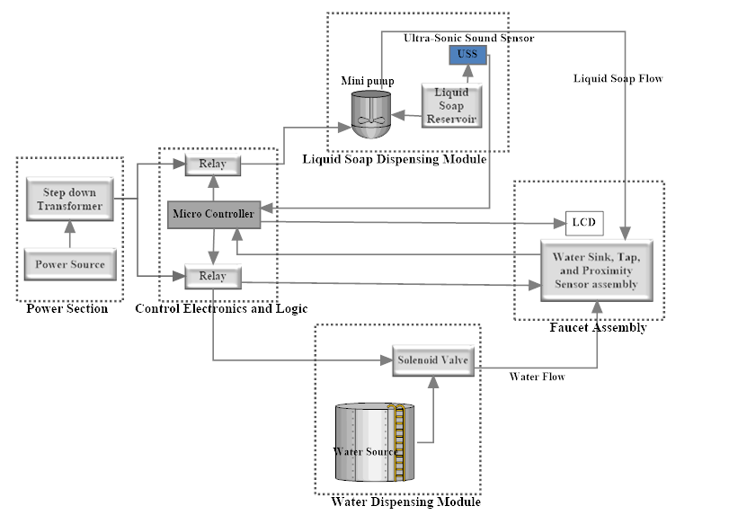

Figure 7: Automatic Faucet System Architectural Design

* **Power section.**

This section is concerned with the conversion of AC power to DC. The step down transformer helps in reducing the voltage levels to the system specifications in what is known as stepping down the current. The obtained direct current is then supplied to the rest of modules that make up the system.

* **Control electronics and logic.**

This section is made of the necessary electronics needed to run the system. The most vital of it all being the Atmel ATmega328 microprocessor. The program code for the system is uploaded on the microprocessor and it defines the different actions the microprocessor takes in response to given actions or triggers from the proximity sensors. It is able to execute such actions through the output of electrical signals to other control electronics such as the transistor, the relay among others that also trigger subsequent actions.

* **Liquid soap dispensing module.**

The liquid soap dispensing module is generally concerned with performing the action of releasing liquid soap to the user. The entire module gets into operation an electric signal from control electronics and logic area is received by the mini pump, a major component of this module. A number of readings from this module are constantly sent to back to the control electronics and logic area. The messaging assumes a unidirectional mode of communication between the two modules. The readings contain the level of the liquid soap in the reservoir.

* **Water dispensing module.**

This module is primarily concerned with the flow of water when triggered by the control electronics and logic area. It is made up of the solenoid valve, a key component concerned with the stopping and releasing of water siphoned from a tank at a higher point of elevation. Its actions are triggered by the microcontroller. This module provides a supply of water to the faucet assembly.

* **Faucet assembly.**

Perhaps one of the most important components of the system architecture, the faucet assembly is where the user interacts with the system. This assembly is comprised of the proximity sensors for the detection of hands, water and liquid soap spouts for the release of water and liquid soap respectively. The water spout is connected to the solenoid valve while the liquid soap spout is connected to the mini pump for their respective outputs.

With a proper configuration of the system, the sequence of actions starts when hands are detected on one of the spouts, to the control electronics and logic area and then the routing of current to one of the two modules by the help of the relays.

**b). State machine for the Automatic Faucet System**

The state diagram is a UML based modelling visual paradigm that is meant to show the different states the automatic faucet system is to traverse during its operation. The system will start in a waiting state where no hands are sensed in close proximity (proximity is greater than 160mm) and therefore unattended to. At this point the power supply throughout the system will only be 9 volts that will be reduced to 5 volts as it traverses through the connecting circuitry to the proximity sensor. The proximity sensor will in turn emit infrared to detect any presence of hands. This is what defines the waiting state.

Once a user draws hands closer (proximity less than or equal to 160mm), a signal will be reflected from the hands (backscatter signal) back to the proximity sensor. This initiates the sensing state of the system.

Depending on which proximity sensor the user’s hands will be drawn close to, the decision of whether to use water or soap first shall define the next state the system will be transitioning to. If the user chooses to use water, the proximity sensor produces an analog signal which will be received by the microcontroller. The microcontroller will in turn send an electrical signal to the relay to complete the circuit thus trigger the solenoid valve to allow water flow. By the relay completing the circuit, the total voltage of the system increases when 12volts is supplied to the solenoid valve. The water will flow for as long as the user’s hands remain in close proximity. This is what defines the water flow state.

Similarly, when the user chooses to use liquid soap by drawing hands closer to the proximity sensor mounted on the liquid soap spout, the proximity sensor produces an analog signal which will then be received by the microcontroller. The microcontroller will in turn send an electrical signal to the relay to complete the circuit thus triggering the pumping of liquid soap from the reservoir through the spout to the user by the mini pump. Once again, the voltage of the system increases when it connects 12 volts to the mini pump. The liquid soap flows for as long as the user’s hands remain in close proximity but in a controlled manner of short time delays using timers. This is what defines the soap flow state.

However, in case there ceases to be any liquid soap, that is to say, liquid soap being below the minimum level in the reservoir, the microcontroller through the ultrasonic sound sensor is able to tell that the liquid soap level is below the minimum required level or completely used up. It will in turn send a message to a small LCD hinged on the wall to display the message that reservoir is out of soap. This defines the out of soap state. Upon refilling of the reservoir with more liquid soap by the concerned personnel (sanitary workers), the message on the display will be updated and the system transitioned back to the soap flow state provided the user’s hands are maintained in close proximity. Note that between the time when the reservoir is out of liquid soap and the time it is refilled, the system is transitioned to the no flow state.

When the user is done with using the faucet and his or her hands are moved out of range (proximity greater than 160mm), the dispensing of either fluids is suspended and both relays (water and soap module relays) are disconnected. This defines the no flow state. This means that voltage will be returned back to 9volts enough to do the sensing of the next user’s hands and powering the control electronics thereby transitioning back to the waiting state, the first state of the system.

**The state machine diagram**

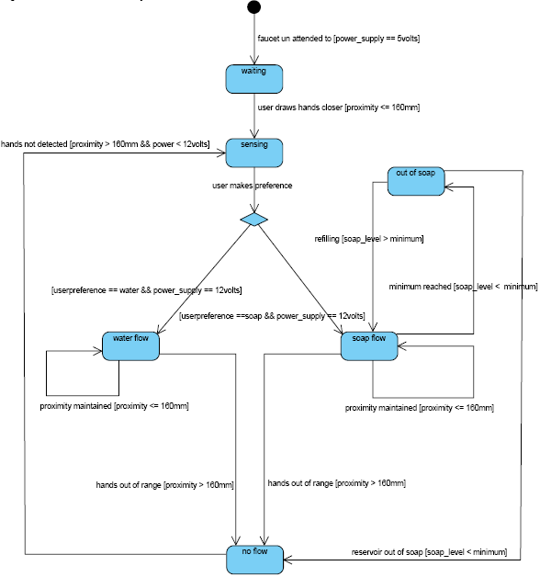

Figure 8: State machine diagram of the Automatic Faucet System

**c). Sequence diagrams**

A sequence diagram is an UML based modelling technique that emphasizes the time ordering of messages, showing the set of objects and the messages sent and received among these objects. The system is logically divided into two modules which are, the water dispensing module and the liquid soap dispensing module. The two modules form the automatic faucet system.

1. **Sequence Diagram for the water dispensing module**

The sequence diagram for the water dispensing module within the automatic faucet system is concerned with the objects (components) and their interactions in form of messages and responses while performing their primary functions necessary to automatically dispense water to the user.

The power source constantly provides a 9V supply to the microcontroller (1) which in turn supplies 5V to the proximity sensor (2). The proximity sensor in turn emits infrared light (2.1). The infrared light propagates through air and when it hits a person’s hands, it is reflected back towards the proximity sensor (2.1.1) and converted into an electric signal (3) that is sent to the microcontroller (4).

The microcontroller executes an instruction set upon receiving the electric signal (4.1)from a known analog pin on the logic board on which the microcontroller is housed. The microcontrollerthen sends an electric signal to the relay (4.2) connected to a known output pin on the same logic board. On receiving the electric signal, the relay completes the circuit (5) and supplies the solenoid valve with 12V (6). The supply is due to the magnetization that ceases to exist when the electric signal to the relay is no longer received.

If the user’s hands’ are maintained in a position detectable by the range of the emitted infrared light from the proximity sensor, water is dispensed (7)for as long as the user maintains proximity else, the electric signal is cancelled (8) and the relay disconnects the high voltage supply (8.1) from the solenoid valve. This means that no more water is dispensed by the solenoid valve (9).

**Sequence diagram for the water dispensing module**

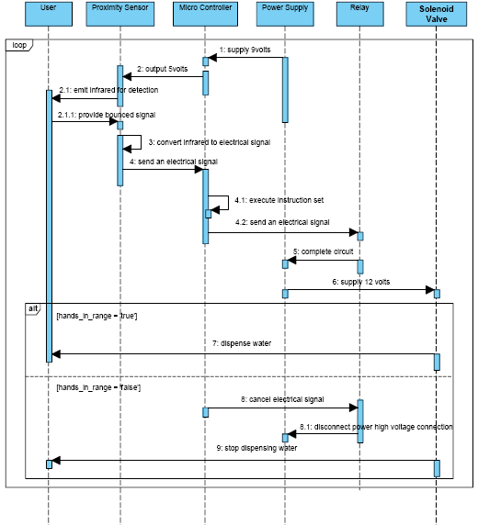

Figure 9: Sequence diagram of the water dispensing module.

1. **Sequence Diagram for the soap dispensing module**

The sequence diagram for the soap module is concerned with the objects (components) and their interactions in form of messages and responses while performing their primary functions necessary to dispense liquid soap to the user.

Unlike the water dispensing module, the liquid soap dispensing module includes quite a few more objects and these are the mini pump, ultrasonic sound sensor, and a mini liquid crystal display (LCD) screen. The other components or objects common between the two modules are the proximity sensor, microcontroller, power supply, relay, and the user.

The sequence of actions will start with the power source supplying 9V to the microcontroller.The microcontroller then supplies 5V to the LCD in order to provide the powering status of the system. In just a negligible time frame, the microcontroller also powers the ultrasonic sound sensor with a 5volt power supply and thereafter powering the proximity sensor in just the same way. The proximity sensor then emits infrared light. The infrared light propagates through air and when it hits a person’s hands, it’s reflected back towards the proximity sensor and it is converted into an electric signal. The electric signal is sent back to the microcontroller.

The microcontroller executes an instruction set upon receiving the electric signal. The instruction set will be selected depending on the analog pin on the logic board which the proximity sensor transmits the signal to (through a jumper wire).Depending on the level of liquid soap available in the reservoir as determined by the ultrasonic sound sensor and then provided to the microcontroller, one of two actions can be taken. If the soap level reading is above a pre-set minimum, the microcontroller will send an electric signal to the relay. On receiving the electric signal, the relay completes the circuit and from the DC power source comes a 12V power supply to the mini pump. At this point, a user will be provided with liquid soap for just a short while to prevent the wastage of the scarce fluid, soap. This will be through the use of a delay timer for the flow.

Alternatively, if the liquid soap reading is below the minimum level, the microcontroller will instead issue an instruction to the LCD to display an out of liquid soap message to the user. Each of the instructions will be executed only if the user’s hands remain in a detectable range of 160mm. Any distance slightly beyond that, the signal strength may not be good enough to trigger subsequent actions through the microcontroller.

On the contrary, if the user’s hands are in an undetectable range, that is to say, the user does not maintain proximity, the microcontroller cancels the electric signal to the relay upon not receiving any incoming analog signal (electric signal) from the proximity sensor. Note that the backscatter off the user’s hands is used to generate the incoming analog signal by the proximity sensor with the help of its highly electrical conducting material, graphene. When the microcontroller cancels the electrical signal to the relay, the relay’s coil is demagnetized thereby disconnecting the heavy load power supply. By disconnecting the heavy load power supply, the heavy load components cannot run and in this case the mini pump can no longer generate the suction force that is needed to pump soap through the spout. This means that no more liquid soap is dispensed in the absence of a user. Heavy load components on the other hand are the electronic appliances that require higher voltage level than the average components such as transistors.

**Sequence Diagram for the liquid soap dispensing module**

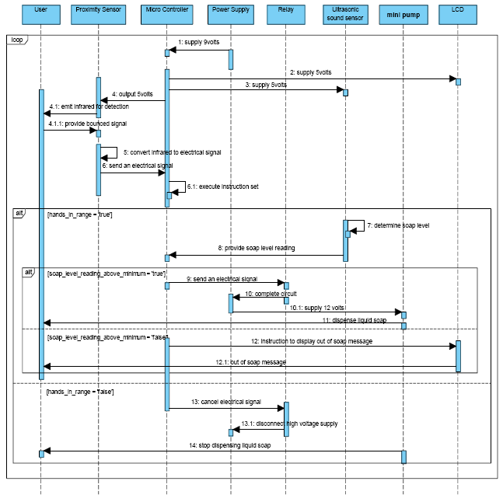

Figure 10: Sequence diagram of the soap dispensing module.

**Note:**

* The process for the two modules is iterative.
* The human body and many other materials naturally emit a certain level of infrared. The implications of this natural phenomenon are however not good as the infrared emitted off the human body cancels out with the much stronger infrared emitted by the proximity sensor. With that in mind, a certain level of inaccuracy will be expected in the detection process.

# Chapter 5

## System Implementation, Testing& Validation

The chapter describes the development, implementation and testing process of the design of the automatic faucet system. This is a very relevant stage of the system development life cycle (SDLC) of new systems and when handling changes subjected to the existing systems (current water installations).The output from this stage of the SDLC is an approved system (automatic faucet) for subsequent inspection and testing. It also describes the implementation of the design of the automatic faucet system which is presented in the previous chapter.

The objectives of this phase are;

1. To determine the expected design outcome of the automatic faucet system.
2. To review tasks and activities that need special consideration in the design and implementation.
3. To review the time schedule of the specific activities in the design and implementation process of the automatic faucet.

### 5.1 System Development& Implementation

The technologies used at this stage were selected according to availability and ease of use as discussed below. To be able to implement the design, the following technologies were used.

#### 5.1.1 Software Technologies.

|  |  |
| --- | --- |
| **Technology** | **Relevance** |
| Arduino platform | IDE used to write the functionality of the system in C programming language. |
| C Programming Language | Programming language in which code was written for the system. |
| Fritzing | IDE used to design the circuits on which the code is to operate. |
| Operating System (Windows 8 ) | Provided a suitable platform for the Arduino IDE. |
| LCD library | Facilitate interaction between the LCD screen and the Arduino board. |
| LCD Bar Graph V.1.3 | Enables the represent of given measurements inform of bars. |
| Ultra-Sonic Sound Sensor library | Facilitate interaction between the ultra-sonic sound sensors with the Arduino board. |

Table 3: Software Technologies used to develop the Automated Faucet System.

#### 5.1.2 Hardware Technologies.

|  |  |
| --- | --- |
| **Technology** | **Relevance** |
| Arduino UNO Board with the Atmel ATmega328 microcontroller | Provides a way to enable us insert the code into the ATmega328 microcontroller. |
| Solenoid Valve | Regulates water flow. |
| Mini pump | Pump and regulate liquid soap flow. |
| Proximity sensor | Emits infrared light which it detects upon reflection when it has hit an obstacle (hand). |
| Resistor | Regulator amount of current heading to proximity sensor. |
| Adapter | To supply direct current (DC) to the respective electric components. |
| Relay | Switches on and off the respective component connected to it. |
| Transistor | Trigger the relay. |
| Liquid Crystal Display (LCD) | Provides relevant information about the level of soap in the repository. |
| Ultra-Sonic Sensor | Measure the level of soap remaining in the soap repository and send feedback to the LCD screen. |
| Diode | Prevent back electro motive force from destroying sensitive components. |
| Jumper wires | Provide interconnection between the different electronic components. |

Table 4: Hardware Components used to implement the Automated Faucet System.

#### 5.1.3 Implementation of the Hardware and Software Technologies.

Arduino open source software was used by the development team to write code in C programming language and specify functionality according to the user requirements. First and foremost, the C code for specific electronics like proximity sensor, ultra-sonic sensor and LCD screen was written separately. Each time C code was written for a specific electronic, it was inserted into the micro controller on the Arduino UNO board via a USB cable from the computer to power it up so as to carryout processing and instructing that specific electronic plus other electronics connected to it respectively.

Two proximity sensors were used, one for the soap sprout and the other for water sprout. Both were just constructed using an IR LED receiver (photodiode) and IR LED emitters. The anode of the IR LED receiver was connected to a resistor (1000 Ohms) which in turn connected to the 5V pin of the Arduino UNO board. It was also connected to the analog pin A0. The anode of the IR LED emitters connected to digital pin 2 on the Arduino UNO board and all the cathodes of both the IR LED receiver (photodiode) and IR LED emitters connected to ground pin. This set up was done for the other proximity sensors using analog pin A1 and digital pin 3 for the IR LED receiver and emitters respectively.

Since Arduino UNO board could not control heavy loads that draw large amounts of current, an electric set up was built by the developer team to cater for this. A 12V relay with 5 legs was connected to the breadboard with its common terminal and one of the coil terminals were connected to positive 12V power supply. The other coil terminal connected to the collector leg of the transistor. The normally open terminal connected to the positive side of the solenoid valve and negative side of the solenoid valve connected to ground. The base of the transistor was connected to pin 8 on the Arduino UNO board to receiver an electric signal and be able to trigger the relay. A diode was put across the coil terminals to prevent back flow of current (EMF) from the coil of the relay since it destroys the transistor. Another diode was connected between the base of the transistor and the jumper wire from pin 8 to prevent back flow of current to the Arduino UNO board. Same set up was used for the pump but with pin 9 connected to the base of transistor.

LCD screen was connected unto the breadboard with its pin 16 connected to ground and pin 15 to +5V of the Arduino UNO board. The Arduino was connected up to power to check if the backlight lights up. The contrast pot was plugged into the breadboard having its one side connected to +5V and the other to Ground (it doesn't matter which goes on what side). The middle of the pot (wiper) connected to pin 3 of the LCD. We wired up the logic of the LCD which is separate from the backlight. Pin 1 connected to ground and pin 2 is +5V. The Arduino was turned on to test the contrast pot by twisting it back and forth and the first line of rectangles appeared.

The RW (read/write) pin which is pin 5 on the LCD screen was tied to ground since we were not to use it. Next the RS pin #4 was connected to Arduino's digital pin #7 and the EN (enable) pin #6 connected to Arduino digital #8. The data pins were connected next as follows DB7 is Pin #14 on the LCD, and it was connected to Arduino pin #12,DB6 (pin #13 yellow), DB5 (pin #12 green) and DB4 (pin #11 blue) were connected to Arduino #11, 10 and 9 respectively. We were left with a gap of four pins on the LCD screen between the 4 data bus wires and the control wires.

In order to be able to know the level of liquid soap remaining in the repository, an ultra-sonic sensor was plugged into the breadboard with its ground pin connected to ground of the Arduino, the VCC (power pin) connected to the Arduino 5V pin, the trig. Pin connected to pin 7 on the Arduino and the echo pin to pin 6 so that after taking the reading it sends the result onto the LCD screen connected earlier long.

**N.B:** The Interconnections between the different electronic components were aided by the jumpers plus the breadboard.

### 5.2 System Testing & Validation

#### 5.2.1 System Testing

A systematic testing procedure was followed to test this system in order to determine if it reflects the requirements. The development team made use of some students to use the system to test for its proper operation. The system was found to be executing as expected by the user requirements. System testing is done in a real world environment. The system was installed in a rest room, ready for use. A group of 10 students was randomly chosen to test the system, identify possible errors and missing features. The group was made to use the system to wash their hands, using both water and soap. The purpose of testing was to eliminate any unresolved errors.

The errors that were found to be still hindering system operation were identified. These errors were removed by modifying the software that runs that system. The system was then ready for the final testing, by real world users and it was found to be perfect.

#### 5.2.2 System Validation

The system was used and tested on different categories of users. Through this, a validation was conducted where the users validating had forms to fill in and evaluate the system. After each user using the system in the testing phase, he/she was given a form to fill in and evaluate the functionality of the system. The function of validationprocess is to determine whether the right system was developed for the users and will satisfy their expected needs.

Of the 10 students that were chosen to test the system, 7 said they were satisfied with the system. They stressed that the system properly fulfilled all their expectations from an automated faucet system. However, 3 of the users said they were not satisfied with the system. They stressed dissatisfaction regarding the fear of radiation from infrared emitters which is the cause of most cancer infections these days.

# Chapter 6

## Discussion, Conclusion & Recommendations

This chapter gives a brief description of the system achievements, our experiences, limitations and the recommendations.

### 6.1 Discussion

This developed automated system helps mitigate the spread of contagious diseases like Ebola by automatically dispensing liquid soap and water when a person draws his or her hands next to the faucet spout. This reduces physical contact of people with the faucet taps which are more likely to be contaminated. The automatic faucet also reduces water wastage by automatically regulating the water flow.

We carried out a successful investigation on the current water supply installations at different faculties of the University using a number of methods like observation, interviews and questionnaires. The model of the system was then effectively designed using sequence diagrams, state diagram and a block diagram. We then implemented a working model of the system successfully. Testing and validation of the system was also done successfully. The system is able to;

* Sense the presence of a human hand and dispense soap or water.
* Stop soap or water flow when the person removes the hand.
* It is able to display that there is no more soap via an LCD screen.
* It is also easy and convenient to use.

#### 6.1.1 Achievements

This section is an explanation of our experiences and achievements throughout the process of designing and implementing the automatic faucet system.

Makerere University being a public place, the risk of contracting infectious diseases like Ebola is very high. This is because of the physical contact with the manual taps in toilets that could have been touched by an infected person. There was a need for an automatic faucet that does not require physical contact for the person to wash hands.

The period of designing and developing the automatic faucet system was a great experience to us in a number of ways. Firstly, we were able to learn, interact and use electronic components like solenoid valve, relay, and mini pump among others. We were also able to learn how to program hardware using Arduino open source software together with C programming language. Secondly, we were able to interact with a great number of people during data collection hence improved our interview skills. We also gained experience in collecting and analysing the collected data and present the results in excel spread sheets. This further improved our report writing skills as we were able to report our findings and system documentation in a report.

Lastly, the use of different modelling tools such as smart draw, Microsoft Visio, Visual Paradigm among others helped develop our skills in the modelling of the components, processes and transitions. More on to that, schematic designing tools like Fritzing and Smart Draw greatly improved our system modelling skills further.

#### 6.1.2 Limitations

* Developing the system required a lot of funds as we had to purchase equipment like transistors, microcontrollers, relay, and proximity sensors among others. In addition to this, some of the components were not readily in Uganda so we had to import them like the water pump and the solenoid valve.
* Another limitation was inadequate time as we had to prepare for two rounds of tests, exams and the course works hence had to abandon the project for a while. In addition to this the project was done amidst lectures.
* In addition to that, we had limited time to test and validate the system. Because we had to get a number of students interact with the system and give us responses basing on the level of their satisfaction.

### Conclusion

Although manual taps improve personal hygiene through hand washing, these have not been effective enough in improving public health as they can be a platform for transmitting infectious diseases because of the direct physical contact. The automatic faucet automatically dispenses water and liquid soap when it senses a human hand in close range. This in turn reduces the spread of contagious disease as they do not require physical contact with the person’s hands. In addition to that Automatic faucets reduce water wastage because the system automatically stops the flow of water or liquid soap when the person’s hands are out of range. It is convenient and easy to use since it eliminates the winding and unwinding of the taps as well as improve personal hygiene through an automated provision of liquid soap for washing hands after visiting a toilet.

### 6.3 Recommendations

1. The system is able to notify the users about the shortage of liquid soap through the LCD. This also includes the sanitary workers. This method of notifying users is quite ineffective as this requires them to constantly check on the mini LCD screen to see the current level of liquid soap and refill the reservoir when necessary. We therefore recommend that the system be integrated with mobile technology such that the sanitary workers are able to receive notifications about the outage of liquid soap from the reservoir. Any different mechanism of notifying workers could also be of great importance.
2. For purposes of tracking and monitoring the usage of the important resources such as liquid soap, the system should be enhanced by developing an algorithm for it to measure the amount of liquid soap used at the end of the month or any time interval. This could provide accountability for how such a vital resource is used.
3. We recommend that the system is enhanced such that it’s able to determine the rate at which the liquid soap reservoir runs out of soap during specific times of the day. This is essential in providing the sanitary workers with a rate at which the liquid soap can be refilled during specific times and therefore maintain close monitoring.
4. Furthermore, liquid soap can be too viscus. This in turn affects the rate at which the liquid soap can be pumped to the users’ hands. The system relies on a timer that defines the amount of time for which the liquid soap can be pumped when a user’s hands are detected. The time it takes the liquid soap to move up the tube through which liquid soap is pumped also adds an inaccuracy to the supply of liquid soap. The timer may therefore expire before the user is given any soap. We therefore recommend that a sophisticated algorithm that considers the viscosity of the liquid, the length and diameter of the tube provides direction for future research in order to improve the services offered by the system. The results of this algorithm should lead to the generation of appropriate and dynamic timers given the above parameters.

## References

1. Arizona State University. (2014, September 11). Ebola paper demonstrates disease transmission rate. Science Daily. Retrieved February 22, 2015 from http://[ww.sciencedaily.com/releases/2014/09/140911130048.htm](http://www.sciencedaily.com/releases/2014/09/140911130048.htm).
2. Auto. (2014). Automatic taps facts and charts. Retrieved on March 19th, 2015 from <http://www.autotaps.com/sensor-taps-facts-and-charts.html>
3. Asian Enticement. (2010). Benefits of a Touchless Soap Dispenser and Faucet. Retrieved Feb 23, 2015, from

<http://www.asianenticement.com/benefits-of-a-touchless-soap-dispenser-and-faucet/> .

1. Centre for Disease Control and Prevention. (November 6, 2014). HOW EBOLA IS SPREAD. Retrieved on February 22, 2015 from <http://www.cdc.gov/vhf/ebola/pdf/infections-spread-by-air-or-droplets.pdf> .
2. Chicago Faucets. (ND). Company Profile, retrieved on 19th march 2015 from <http://www.chicagofaucets.com/chicagofaucets.html>
3. DeCriscio, D. (2014). Selecting the Right Dispensing System can help reduce restroom Bacteria. Retrieved on February 23, 2015, from <http://www.facilitymanagement.com/articles/maintenance1-0310.html>.
4. Fadi. S, (ND). The Story of Mac Faucets. Retrieved on 10th March 2015 from <http://www.macfaucets.com/index.html>.
5. Garrett.H, Raihan.K and Will. (ND) Infrared Proximity Sensor. Retrieved March 10 2015, from <http://www.g9toengineering.com/AllSaints/infraredproximity.htm>
6. Griffiths, D. (2012). Introduction to Electrodynamics(3rd edition).
7. Infection Control Today (ICT). (Sept 1 2007). Touchless Technology Helps Facilitate Infection Prevention. Prevention Best Practices. Retrieved Feb 24, from <http://www.infectioncontroltoday.com/articles/2007/09/touchless-technology-helps-facilitate-infection-p.aspx>
8. Julien, B. (2013). C Programming for Arduino. Birmingham B3 2PB, UK, Packt Publishing Limited.
9. Larissa. H. (Mar 06, 2012). What’s the difference between infectious and contagious? Retrieved on 25th February 2015 from <http://kidshealth.org/teen/experts/illness/contagiius/contagious.html>.
10. Mac Faucets Inc., How Automatic Faucets Work. Retrieved on 7th March 2015 from <http://www.macfaucets.com/how-automatic-faucets-work.html> .
11. Mark, P. (September 15 2013). Graphene makes light work of optical signal. Retrieved March 13 2015, from [http://www.nature.com/news/graphine -makes-light-work-of-optical-signals-1.13744](http://www.nature.com/news/graphine%20-makes-light-work-of-optical-signals-1.13744).
12. Michael, C. (2015). What’s the healthiest faucet for washing hands? Retrieved March 18th, 2015 from <http://www.mcknights.com/whats>_the_healthiest_faucet_for_washing/articles/392318
13. Michael, M. (2008). Beginning Arduino. New York, Paul Manning.
14. Moen Inc. (ND). Motion sense Hands Free Faucet, retrieved on 19th march 2015 from <http://www.moen.com/innovation.html>
15. Notier, R. (2014). Hands Off! Touchfree Faucets are Important Germ-Fighting Tools. Retrieved February 24, 2015, from <http://facilitymanagement.com/articles/maintenance5-0209.html>
16. Office of the Provincial Health Officer, Ministry of Health, Province of British Columbia, Public Health in British Columbia. Retrieved on February 22, 2015 from <http://www.health.gov.bc.ca/pho/why-public-health-important.html> .
17. Penn State University News. (December 20, 2010). How Contagious Diseases Spread through communities. Retrieved on March 10th 2015 from <http://publications.nigms.nih.gov/computinglife/contagiousdisease.html>
18. Sloan Valve Inc. (ND), Sensor Faucets. Retrieved on 9th March 2015 from <http://www.sloanvalve.com/Our_Products/Sensor_Faucets.aspx> .
19. Wikipedia 2014, Automatic Faucet retrieved on 2nd March, 2015 from <http://en.wikipedia.org/wiki/Automatic_faucet>.
20. Wikipedia. (2015). Faucet. Retrieved March 20th, 2015 from http://en.wikipedia.org/wiki/Taps_(valve).

## Appendices

### Appendix A: Research Tools

#### Questionnaire

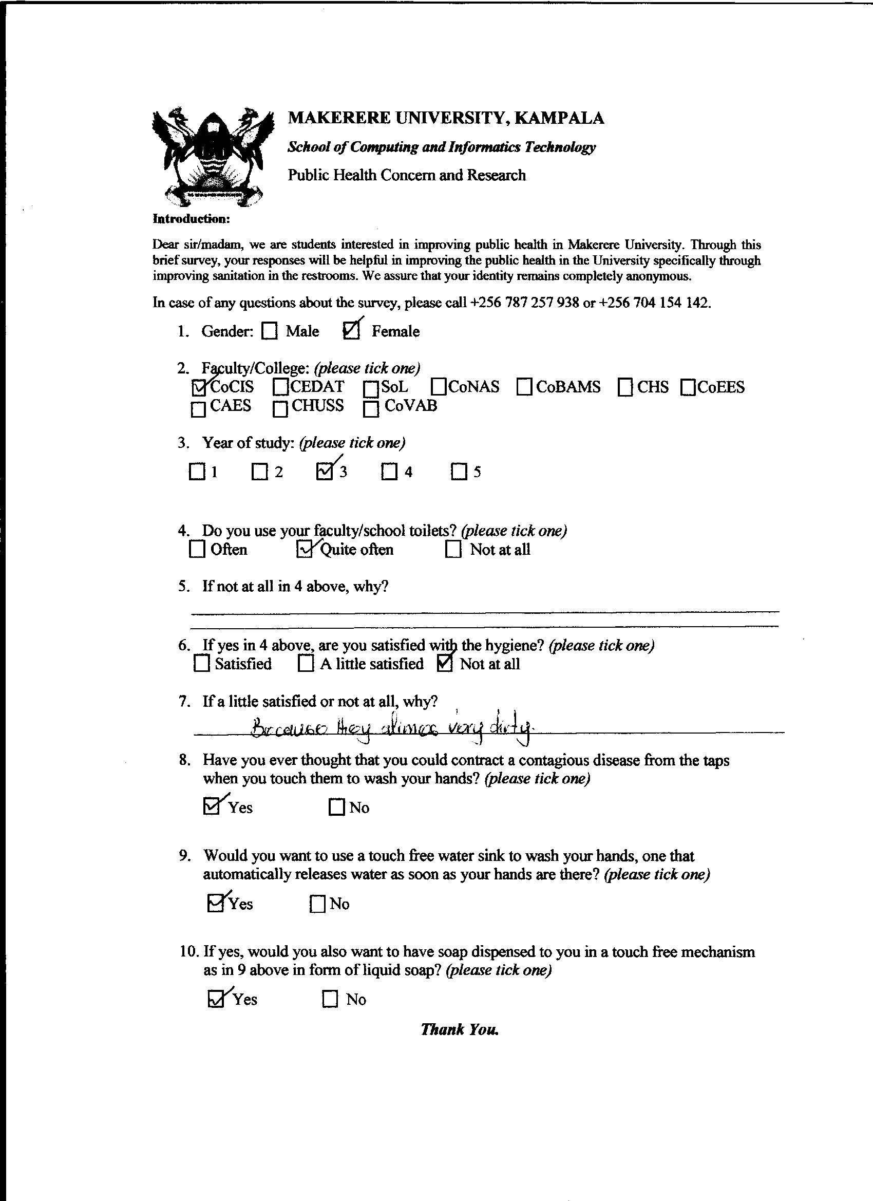

Figure 11: Questionnaire used to collect data

#### Observation Checklist

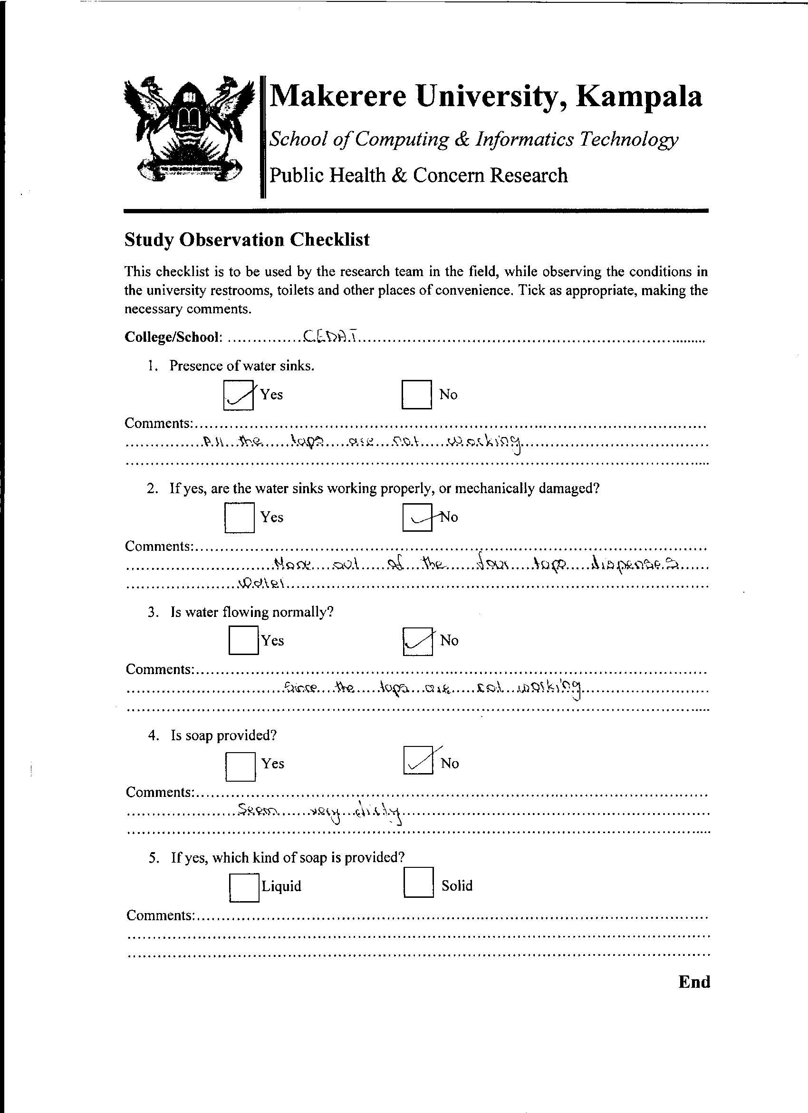

Figure 12: Observation Checklist used during the observation process.

#### Interview Guide

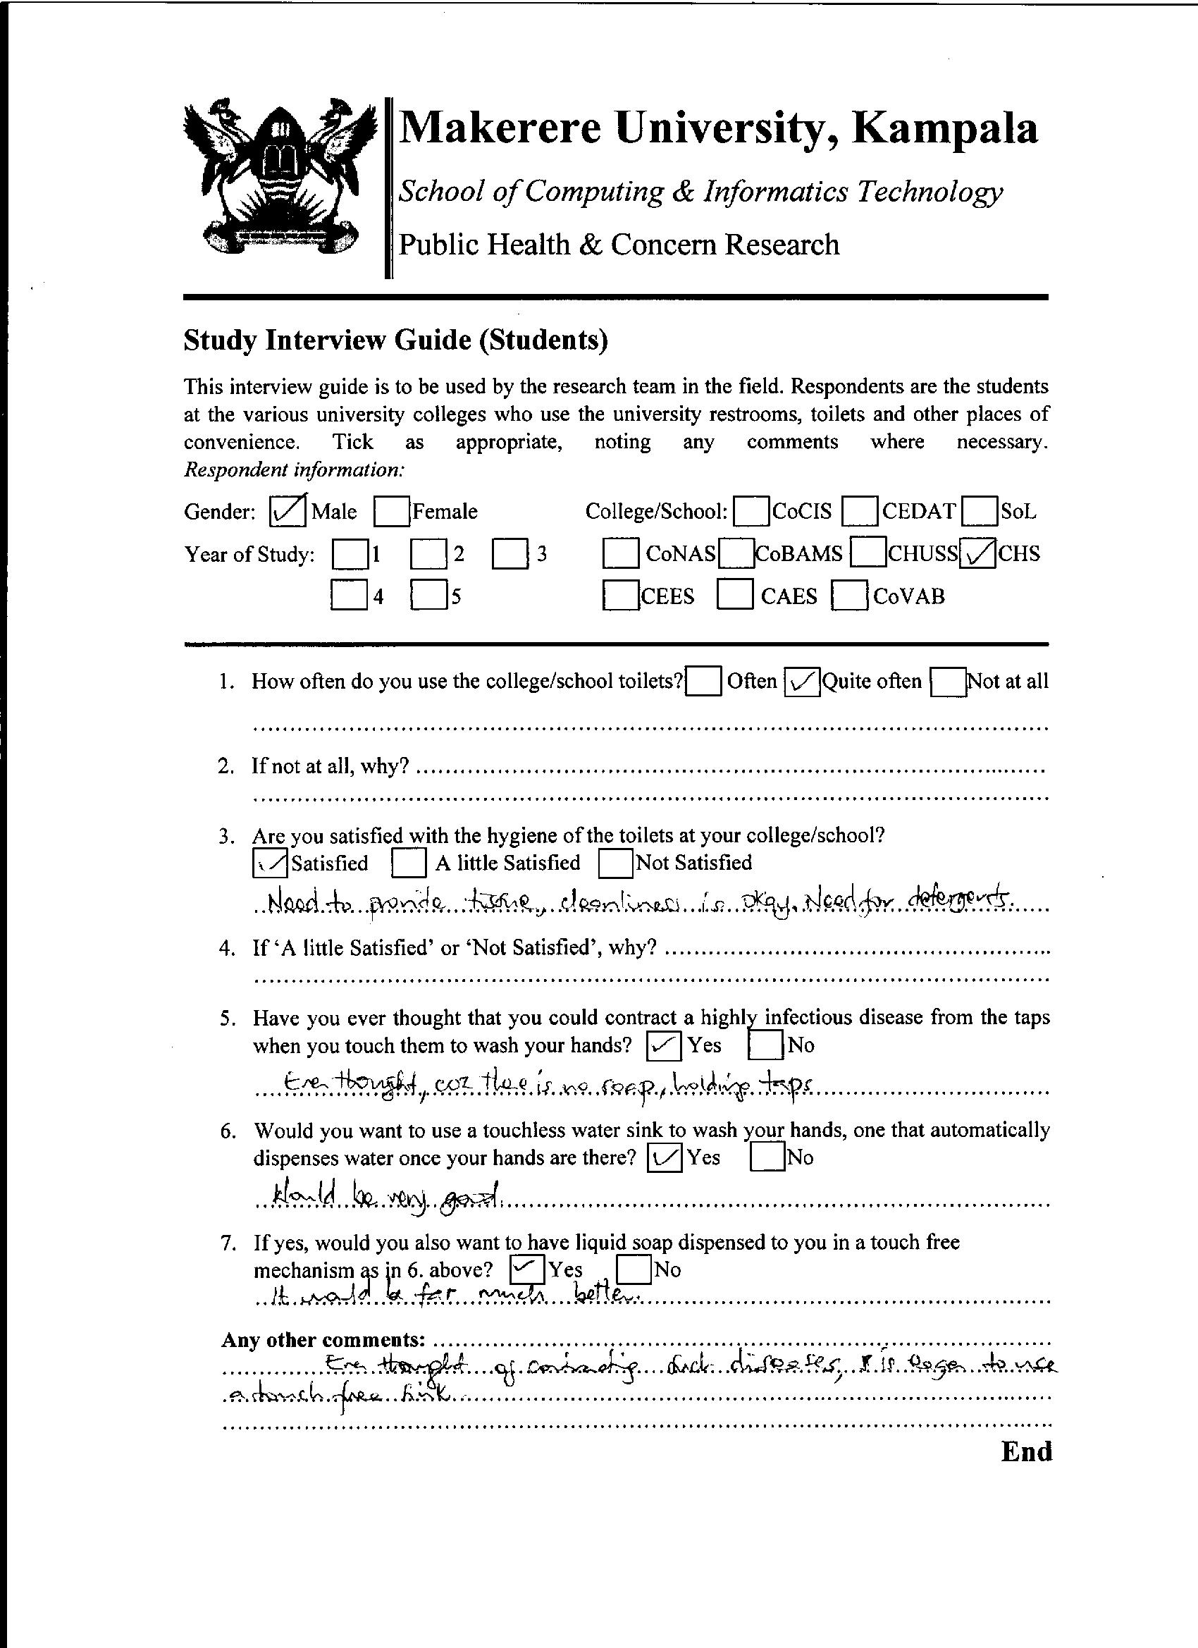

Figure 13: Interview Guide used during data collection

### Appendix B: Work Plan

**Goal:**To develop an automatic faucet to aid in the control of the spread of infectious and contagious diseases.

|  |  |  |  |  |
| --- | --- | --- | --- | --- |
| **Activities** | **Task** | **Timeline** | **Who was involved** | **Output** |
| Advisory supervisor | Meet the supervisor | Entire project life time | Project team and  Supervisor | Go ahead |
| Concept paper | Write the concept paper | 1 week | Project team | Fully documented concept paper |
| Concept paper approval and submission | Present the Concept paper to the supervisor | 1 day | Project team and  Supervisor | Approved concept paper. |
| Proposal | Write the proposal present it to the supervisor | 2 weeks | Project team and  Supervisor | Fully documented projectProposal |
| Requirements determination | Gather information using observation, questionnaires and interviews. | 1 week | Project team,  Students and  People who have used automatic faucets before. | Gathered Informationready for analysis |
| Analyzing the data | Look through the gathered data | 2 weeks | Project team | Analyzed requirements |
| Designing the system | Using Microsoft Office Visio to design a circuit diagram or system schematics. | 3 days | Project team | Circuit diagram |
| Developing the system | -Connecting components together.  -Writing code. | 1 month | Project team | Working system |
| System Implementation | Installing the system in the toilet. | 2days | Project team | Working system |
| System testing | Identifying and correcting errors plus inconsistences to their acceptable levels. | 3 days | Project team  Supervisors,  students | Fully functional system |
| Report writing | Writing and compiling the report.  Taking of screen shots. | 2 months | Project team  supervisors | Fully documented report. |

Table 5: A table showing the work plan for developing the Automatic Faucet System